- Data reliability concerns continue to plague key official UK economic statistics, while many business surveys have proved very volatile in recent months. Our heatmap of alternative indicators focuses on timely, high-frequency datasets, providing a helpful complement to the existing suite of indicators we use to gauge economic conditions.
- The main takeaway is that most data are consistent with relatively weak economic momentum, but there were no major sources of worry at the end of last year.
- The latest data suggests labour market conditions continue to loosen, while UK goods exports were already in a weak position before this month's spike in trade tensions with the US. Most consumer indicators have improved recently, suggesting households may slowly be shedding the extreme caution of recent years.
Last year, we highlighted widespread issues with several official data series published by the Office for National Statistics. Though improvements have since been made to some series, including the correction of errors in the retail sales and producer prices data, quality concerns in several key areas persist.
At the same time, many survey measures of economic activity have been particularly noisy, partly as a result of swings in sentiment around November's Budget. These measures also continue to have a weak relationship with GDP growth. To help overcome these limitations, we have compiled 17 preferred high-frequency alternative indicators into a heatmap to provide a broad and timely assessment of current conditions in the UK economy (Chart 1). See the Appendix for further details.
Chart 1: A broad sweep of alternative indicators points to a mixed picture for the UK economy
Source: ONS, DfT, Insolvency Service, exactEarth, DESNZ, Indeed, Revolut, Vocalink, EUROCONTROL, Elexon, and ECB

The key takeaway is that although our heatmap shows few areas of emerging concern, the broader picture is one of continued subdued economic momentum, leaving the economy vulnerable to anything that goes wrong.

Consumer spending signals are slowly improving
We have previously argued that the UK lacks a sustainable growth driver, with rising government spending having played an outsized role in the meagre rates of GDP growth we have seen in recent years. Consumer spending growth has been particularly soft, despite a strong recovery in household spending power once the energy price shock had faded. But there are some early signals suggesting that households are starting to slowly shed their extremely cautious attitude to spending and saving.
Weekly Revolut debit card spending gradually strengthened in 2025, particularly in the final few months of the year. What's more, this improvement was relatively broad-based across the various sub-sectors. On the flip side, the amount households are spending on direct debit payments has softened while the failure rate on these transactions has increased. We suspect this may be linked to rising joblessness and slowing household income growth, which are reducing the ability of some households to make regular payments.

Labour demand continues to cool
The labour market continues to be a major source of uncertainty. The Office for National Statistics has made some progress overhauling its troubled Labour Force Survey, but results are still volatile and inconsistent with other sources, while survey sample sizes are still well below pre-pandemic levels. It will be some time until these problems are resolved, with recent media reports suggesting that the ONS is drawing up contingency plans to push the launch of its new Transformed Labour Force Survey from November 2026 to May 2027.
Though the data typically is subject to large revisions, greater reliance on HMRC's monthly count of payrolled employees has helped to fill the void left by the LFS. We also look at a variety of alternative high-frequency data, including those in our heatmap and those we have developed internally with Penta.
Labour demand remained weak through the final months of 2025 and at the start of 2026. Job postings on recruitment site Indeed continue to fall. Meanwhile, in December the number of employees covered by HR1 potential redundancy forms was well above the average of the past two years (Chart 2). But despite some concern in the media about the December increase, and suggestions that it could be linked to fragile corporate sentiment after the Budget in late November, the weekly data indicates that the pickup wasn't sustained through the first part of January. Across the broad sections covered by our heatmap, the labour market appears to be in the poorest shape.
Chart 2: HR1 potential redundancy notifications provide a timely guide to official layoffs
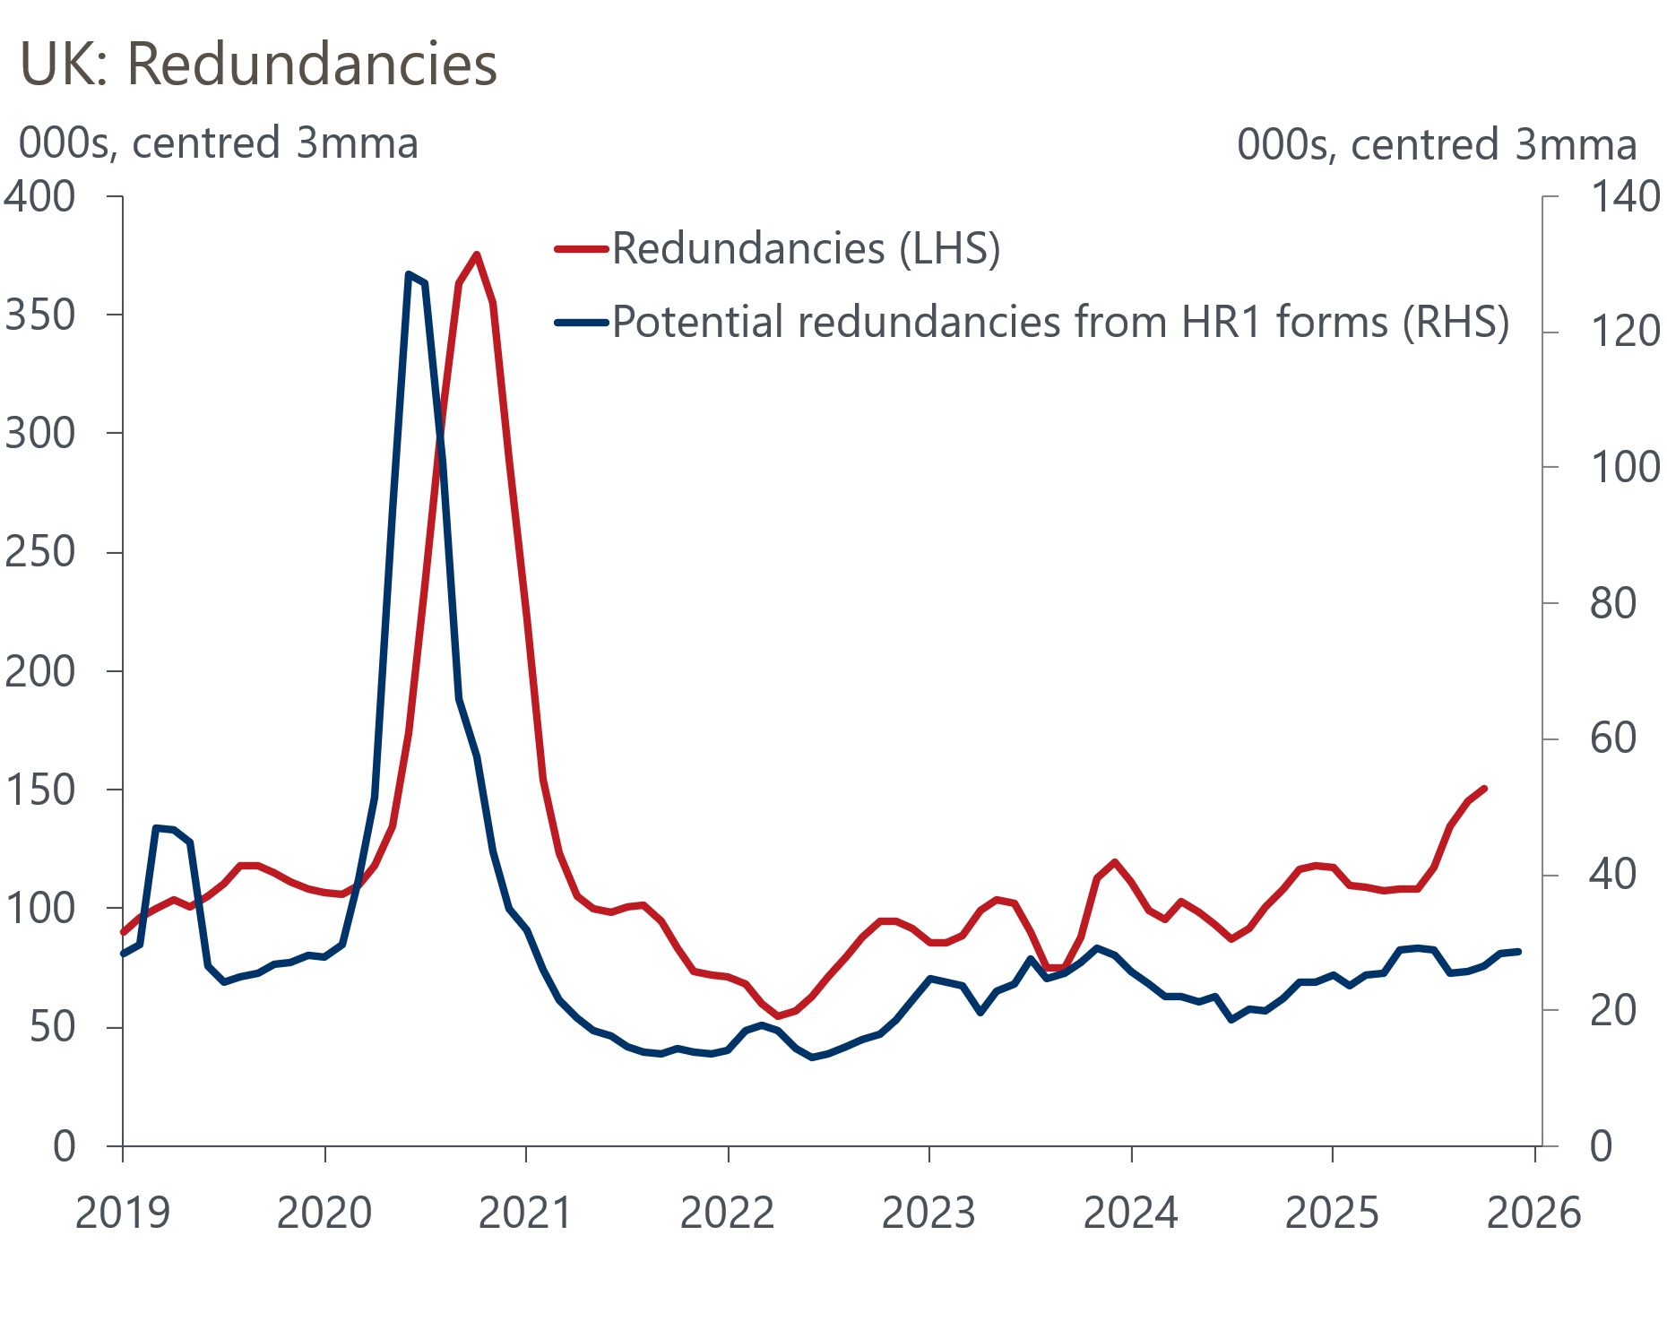
Sources: ONS & Insolvency Services

Goods exports are in a tough spot
UK goods exports have struggled in recent years, falling 7.2% in 2023 and 5.3% in 2024. Last year's rise in US tariffs and associated trade policy uncertainty have contributed to this downward trend continuing. Daily data from exactEarth on the number of unique cargo ship and tanker visits to UK ports weakened considerably after last April's US tariff announcements. Indeed, outturns in November 2025 suggest port visits during the month sat a little over three standard deviations below 2023-2024 levels, and we remain downbeat about the near-term prospects for UK goods exports.

Appendix
Our heatmap uses 17 externally sourced alternative indicators to provide a quick and digestible assessment of where the economy is showing signs of strength and weakness. In most cases, these indicators are captured at a daily or weekly frequency, and can be considered 'hard' data (i.e. actual measured data rather than from surveys).
We ensure the data is seasonally adjusted, before creating a z-score using the 2023-2024 period for comparison. We transform the results into monthly series to reduce noise and improve interpretability. Where higher readings for a given series implies weaker conditions, for example potential redundancies or economic policy uncertainty, we change the sign associated with the z-score. Additionally, series that measure values, such as some of the consumer spending series, have been deflated to capture how the series evolves in real terms.

